Lab 8.4.2: Show IP Route Challenge Lab

Addressing Table
Device | Interface | IP Address | Subnet Mask
R1 | Fa0/0 | 172.16.1.1 | 255.255.255.224
R1 | Fa0/1 | 172.16.3.1 | 255.255.255.128
R1 | Serial0/0/0 | 10.10.10.5 | 255.255.255.252
R1 | Serial0/0/1 | 10.10.10.9 | 255.255.255.252
R1 | Loopback 0 | 192.168.1.1 | 255.255.255.0
R2 | Fa0/0 | 172.16.2.1 | 255.255.255.192
R2 | Fa0/1 | 172.16.3.193 | 255.255.255.248
R2 | Serial 0/0/0 | 10.10.10.1 | 255.255.255.252
R3 | Fa0/0 | 172.16.3.129 | 255.255.255.192
R3 | Fa0/1 | 172.16.1.193 | 255.255.255.248
R3 | Serial0/0/0 | 10.10.10.6 | 255.255.255.252
R3 | Serial0/0/1 | 10.10.10.2 | 255.255.255.252
R4 | Fa0/0 | 172.16.4.1 | 255.255.255.224
R4 | Fa0/1 | 172.16.2.65 | 255.255.255.224
R4 | Serial0/0/0 | 10.10.10.10 | 255.255.255.252
R4 | Serial0/0/1 | 10.10.10.13 | 255.255.255.252
R5 | Serial 0/0/0 | 10.10.10.14 | 255.255.255.252
R5 | Fa0/0 | 172.16.4.129 | 255.255.255.128
R5 | Fa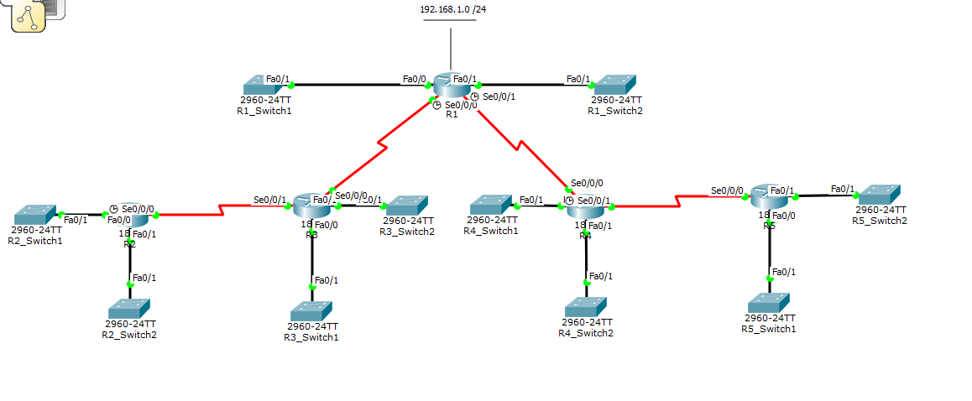0/1 | 172.16.1.33 | 255.255.255.240

Learning Objectives
Upon completion of this lab, you will be able to:
- Determine network topology based on the outputs from the show ip route command.
- Cable a network according to the Topology Diagram.
- Determine router interface addressing based on outputs.
- Perform basic configuration tasks on a router.
- Determine level 1 and level 2 routes.

Scenario
In this lab activity, you will determine the topology of a network using the outputs from the show ip route command. You must draw a topology diagram and determine the interface addressing on each router. Then you must build and configure the network based on the outputs. The DTE and DCE assignment is at your discretion. When complete, the outputs from your network must match those given below.
Task 1: Examine the router outputs.
Step 1: Examine the output from the R1 router.
R1#show ip route
Codes: C - connected, S - static, I - IGRP, R - RIP, M - mobile, B – BGP
D - EIGRP, EX - EIGRP external, O - OSPF, IA - OSPF inter area
N1 - OSPF NSSA external type 1, N2 - OSPF NSSA external type 2
E1 - OSPF external type 1, E2 - OSPF external type 2, E – EGP
i - IS-IS, L1 - IS-IS level-1, L2 - IS-IS level-2, ia - IS-IS inter area
* - candidate default, U - per-user static route, o – ODR
P - periodic downloaded static route
Gateway of last resort is not set
10.0.0.0/30 is subnetted, 4 subnets
R 10.10.10.0 [120/1] via 10.10.10.6, 00:00:09, Serial0/0/0
C 10.10.10.4 is directly connected, Serial0/0/0
C 10.10.10.8 is directly connected, Serial0/0/1
R 10.10.10.12 [120/1] via 10.10.10.10, 00:00:09, Serial0/0/1
172.16.0.0/16 is variably subnetted, 10 subnets, 5 masks
C 172.16.1.0/27 is directly connected, FastEthernet0/0
R 172.16.1.32/28 [120/2] via 10.10.10.10, 00:00:09, Serial0/0/1
R 172.16.1.192/26 [120/1] via 10.10.10.6, 00:00:09, Serial0/0/0
R 172.16.2.0/26 [120/2] via 10.10.10.6, 00:00:09, Serial0/0/0
R 172.16.2.64/27 [120/1] via 10.10.10.10, 00:00:09, Serial0/0/1
C 172.16.3.0/25 is directly connected, FastEthernet0/1
R 172.16.3.128/26 [120/1] via 10.10.10.6, 00:00:09, Serial0/0/0
R 172.16.3.192/29 [120/2] via 10.10.10.6, 00:00:09, Serial0/0/0
R 172.16.4.0/27 [120/1] via 10.10.10.10, 00:00:09, Serial0/0/1
R 172.16.4.128/25 [120/2] via 10.10.10.10, 00:00:09, Serial0/0/1
C 192.168.1.0/24 is directly connected, Loopback0
S* 0.0.0.0/0 is directly connected, Loopback0

Step 2: Examine the output from the R2 router.
R2#show ip route
Codes: C - connected, S - static, I - IGRP, R - RIP, M - mobile, B – BGP
D - EIGRP, EX - EIGRP external, O - OSPF, IA - OSPF inter area
N1 - OSPF NSSA external type 1, N2 - OSPF NSSA external type 2
E1 - OSPF external type 1, E2 - OSPF external type 2, E – EGP
i - IS-IS, L1 - IS-IS level-1, L2 - IS-IS level-2, ia - IS-IS inter area
* - candidate default, U - per-user static route, o – ODR
P - periodic downloaded static route
Gateway of last resort is 10.10.10.2 to network 0.0.0.0
10.0.0.0/30 is subnetted, 4 subnets
C 10.10.10.0 is directly connected, Serial0/0/0
R 10.10.10.4 [120/1] via 10.10.10.2, 00:00:04, Serial0/0/0
R 10.10.10.8 [120/2] via 10.10.10.2, 00:00:04, Serial0/0/0
R 10.10.10.12 [120/3] via 10.10.10.2, 00:00:04, Serial0/0/0
172.16.0.0/16 is variably subnetted, 10 subnets, 5 masks
R 172.16.1.0/27 [120/2] via 10.10.10.2, 00:00:04, Serial0/0/0
R 172.16.1.32/28 [120/4] via 10.10.10.2, 00:00:04, Serial0/0/0
R 172.16.1.192/26 [120/1] via 10.10.10.2, 00:00:04, Serial0/0/0
C 172.16.2.0/26 is directly connected, FastEthernet0/0
R 172.16.2.64/27 [120/3] via 10.10.10.2, 00:00:04, Serial0/0/0
R 172.16.3.0/25 [120/2] via 10.10.10.2, 00:00:04, Serial0/0/0
R 172.16.3.128/26 [120/1] via 10.10.10.2, 00:00:04, Serial0/0/0
C 172.16.3.192/29 is directly connected, FastEthernet0/1
R 172.16.4.0/27 [120/3] via 10.10.10.2, 00:00:04, Serial0/0/0
R 172.16.4.128/25 [120/4] via 10.10.10.2, 00:00:04, Serial0/0/0
R 192.168.1.0/24 [120/2] via 10.10.10.2, 00:00:04, Serial0/0/0
R* 0.0.0.0/0 [120/2] via 10.10.10.2, 00:00:04, Serial0/0/0

Step 3: Examine the output from the R3 router.
R3#show ip route
Codes: C - connected, S - static, I - IGRP, R - RIP, M - mobile, B – BGP
D - EIGRP, EX - EIGRP external, O - OSPF, IA - OSPF inter area
N1 - OSPF NSSA external type 1, N2 - OSPF NSSA external type 2
E1 - OSPF external type 1, E2 - OSPF external type 2, E – EGP
i - IS-IS, L1 - IS-IS level-1, L2 - IS-IS level-2, ia - IS-IS inter area
* - candidate default, U - per-user static route, o – ODR
P - periodic downloaded static route
Gateway of last resort is 10.10.10.5 to network 0.0.0.0
10.0.0.0/30 is subnetted, 4 subnets
C 10.10.10.0 is directly connected, Serial0/0/1
C 10.10.10.4 is directly connected, Serial0/0/0
R 10.10.10.8 [120/1] via 10.10.10.5, 00:00:04, Serial0/0/0
R 10.10.10.12 [120/2] via 10.10.10.5, 00:00:04, Serial0/0/0
172.16.0.0/16 is variably subnetted, 10 subnets, 5 masks
R 172.16.1.0/27 [120/1] via 10.10.10.5, 00:00:04, Serial0/0/0
R 172.16.1.32/28 [120/3] via 10.10.10.5, 00:00:04, Serial0/0/0
C 172.16.1.192/26 is directly connected, FastEthernet0/1
R 172.16.2.0/26 [120/1] via 10.10.10.1, 00:00:03, Serial0/0/1
R 172.16.2.64/27 [120/2] via 10.10.10.5, 00:00:04, Serial0/0/0
R 172.16.3.0/25 [120/1] via 10.10.10.5, 00:00:04, Serial0/0/0
C 172.16.3.128/26 is directly connected, FastEthernet0/0
R 172.16.3.192/29 [120/1] via 10.10.10.1, 00:00:03, Serial0/0/1
R 172.16.4.0/27 [120/2] via 10.10.10.5, 00:00:04, Serial0/0/0
R 172.16.4.128/25 [120/3] via 10.10.10.5, 00:00:04, Serial0/0/0
R 192.168.1.0/24 [120/1] via 10.10.10.5, 00:00:04, Serial0/0/0
R* 0.0.0.0/0 [120/1] via 10.10.10.5, 00:00:04, Serial0/0/0

Step 4: Examine the output from the R4 router.
R4#show ip route
Codes: C - connected, S - static, I - IGRP, R - RIP, M - mobile, B – BGP
D - EIGRP, EX - EIGRP external, O - OSPF, IA - OSPF inter area
N1 - OSPF NSSA external type 1, N2 - OSPF NSSA external type 2
E1 - OSPF external type 1, E2 - OSPF external type 2, E – EGP
i - IS-IS, L1 - IS-IS level-1, L2 - IS-IS level-2, ia - IS-IS inter area
* - candidate default, U - per-user static route, o – ODR
P - periodic downloaded static route
Gateway of last resort is 10.10.10.9 to network 0.0.0.0
10.0.0.0/30 is subnetted, 4 subnets
R 10.10.10.0 [120/2] via 10.10.10.9, 00:00:14, Serial0/0/0
R 10.10.10.4 [120/1] via 10.10.10.9, 00:00:14, Serial0/0/0
C 10.10.10.8 is directly connected, Serial0/0/0
C 10.10.10.12 is directly connected, Serial0/0/1
172.16.0.0/16 is variably subnetted, 10 subnets, 5 masks
R 172.16.1.0/27 [120/1] via 10.10.10.9, 00:00:14, Serial0/0/0
R 172.16.1.32/28 [120/1] via 10.10.10.14, 00:00:17, Serial0/0/1
R 172.16.1.192/26 [120/2] via 10.10.10.9, 00:00:14, Serial0/0/0
R 172.16.2.0/26 [120/3] via 10.10.10.9, 00:00:14, Serial0/0/0
C 172.16.2.64/27 is directly connected, FastEthernet0/1
R 172.16.3.0/25 [120/1] via 10.10.10.9, 00:00:14, Serial0/0/0
R 172.16.3.128/26 [120/2] via 10.10.10.9, 00:00:14, Serial0/0/0
R 172.16.3.192/29 [120/3] via 10.10.10.9, 00:00:14, Serial0/0/0
C 172.16.4.0/27 is directly connected, FastEthernet0/0
R 172.16.4.128/25 [120/1] via 10.10.10.14, 00:00:17, Serial0/0/1
R 192.168.1.0/24 [120/1] via 10.10.10.9, 00:00:14, Serial0/0/0
R* 0.0.0.0/0 [120/1] via 10.10.10.9, 00:00:14, Serial0/0/0
Step 5: Examine the output from the R5 router.
R5#show ip route
Codes: C - connected, S - static, I - IGRP, R - RIP, M - mobile, B – BGP
D - EIGRP, EX - EIGRP external, O - OSPF, IA - OSPF inter area
N1 - OSPF NSSA external type 1, N2 - OSPF NSSA external type 2
E1 - OSPF external type 1, E2 - OSPF external type 2, E – EGP
i - IS-IS, L1 - IS-IS level-1, L2 - IS-IS level-2, ia - IS-IS inter area
* - candidate default, U - per-user static route, o – ODR
P - periodic downloaded static route
Gateway of last resort is 10.10.10.13 to network 0.0.0.0
10.0.0.0/30 is subnetted, 4 subnets
R 10.10.10.0 [120/3] via 10.10.10.13, 00:00:21, Serial0/0/0
R 10.10.10.4 [120/2] via 10.10.10.13, 00:00:21, Serial0/0/0
R 10.10.10.8 [120/1] via 10.10.10.13, 00:00:21, Serial0/0/0
C 10.10.10.12 is directly connected, Serial0/0/0
172.16.0.0/16 is variably subnetted, 10 subnets, 5 masks
R 172.16.1.0/27 [120/2] via 10.10.10.13, 00:00:21, Serial0/0/0
C 172.16.1.32/28 is directly connected, FastEthernet0/1
R 172.16.1.192/26 [120/3] via 10.10.10.13, 00:00:21, Serial0/0/0
R 172.16.2.0/26 [120/4] via 10.10.10.13, 00:00:21, Serial0/0/0
R 172.16.2.64/27 [120/1] via 10.10.10.13, 00:00:21, Serial0/0/0
R 172.16.3.0/25 [120/2] via 10.10.10.13, 00:00:21, Serial0/0/0
R 172.16.3.128/26 [120/3] via 10.10.10.13, 00:00:21, Serial0/0/0
R 172.16.3.192/29 [120/4] via 10.10.10.13, 00:00:21, Serial0/0/0
R 172.16.4.0/27 [120/1] via 10.10.10.13, 00:00:21, Serial0/0/0
C 172.16.4.128/25 is directly connected, FastEthernet0/0
R 192.168.1.0/24 [120/2] via 10.10.10.13, 00:00:21, Serial0/0/0
R* 0.0.0.0/0 [120/2] via 10.10.10.13, 00:00:21, Serial0/0/0

Task 2: Create a diagram of the network based on the router outputs.
Step 1: Draw a diagram of the network based on your interpretation of the router outputs in the space provided below.

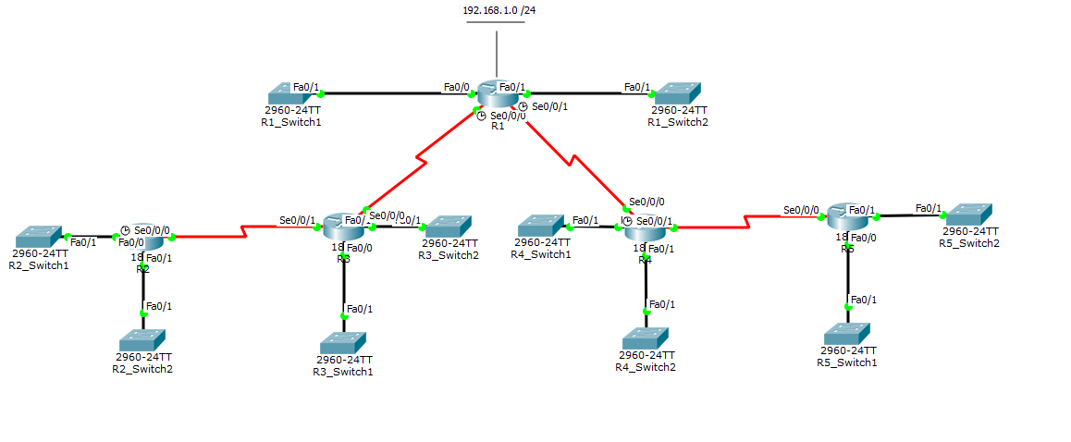
Step 2: Document the interface addresses in the Addressing Table.
Task 3: Build and Configure the Diagram using Packet Tracer.
Step 1: Build the topology diagram in Packet Tracer. Use 1841 or 2811 routers.
Step 2: Configure the interfaces with the appropriate IP address and subnet mask.
Step 3: Configure the appropriate routing protocol for each router and advertise all directly connected networks.
Step 4: Verify that configurations match the router outputs from Task 1.
Task 4: Identify Routing Processes.
Step 1: Examine the R1 routing table.
What are the IP addresses of the directly connected neighbors of the R1 router?
- 10.10.10.4 /30
- 10.10.10.8 /30
- 172.16.1.0/27
- 172.16.3.0/25
- 192.168.1.0/24
Which routes did R1 learn from the directly connected neighbors?
- 10.10.10.0 /30
- 10.10.10.12 /30
- 172.16.1.32/ 28
- 172.16.1.192 /26
- 172.16.2.0 /26
- 172.16.2.64 /27
- 172.16.3.128 /26
- 172.16.3.192 /29
- 172.16.4.0 /27
- 172.16.4.128 /25
Step 2: Examine the R2 routing table.
How many total networks/subnets did R2 learn from its neighbors? 13

Where would R2 send packets to networks not currently in its routing table? Why?

What does the statement “ R* 0.0.0.0/0 [120/2] via 10.10.10.2, 00:00:04, Serial0/0/0” at the end of the R2 routing table represent? Default route →to destination ip 10.10.10.2

Step 3: Examine the R3 routing table.
Which Level 2 routes did R3 learn about from its neighbors?
- 10.10.10.8 /30
- 10.10.10.12 /30
- 172.16.1.0 /27
- 172.16.1.32 /28
- 172.16.2.0 /26
- 172.16.2.64 /27
- 172.16.3.0 /25
- 172.16.3.192 /29
- 172.16.4.0 /27
- 172.16.4.128 /25
- 192.168.1.0 /24
Which networks are directly connect to R3?
- 10.10.10.0 /30
- 10.10.10.4 /30
- 172.16.1.192 /26
- 172.16.3.128 /26
Step 4: Examine the R4 routing table.
Which network is the furthest distance from R4 and how many hops away is it?
Network with ip address 172.16.2.0 /26. Distance → 3 hops.

How many usable host addresses are on the network furthest from R4? 62 usable
Step 5: Examine the R5 routing table.
How many routers must a packet pass through to get from R5 to network 172.16.2.0/26? 4
Why is the “Gateway of last resort” for R5 listed as 10.10.10.13?
_____________________________________________________________

